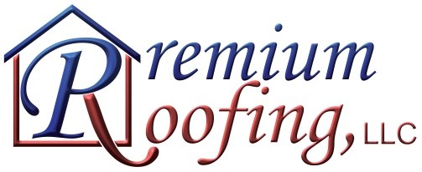

WARRANTY

Premium Roofing LLC warrants all workmanship performed on your property for a period of five years. We are committed to our tradition of quality and service based on our past decade of experience. Our labor warranty is non-transferrable unless stated in the contract. If stated, transferee must provide contract for any service requests.

Our warranty includes all services provided to repair shingles and/or flashing and replace with new shingles and/or flashing.

This labor warranty becomes effective upon the completion of your roofing project as well as payment in full.

Limitations of Coverage:
- Premium Roofing LLC is not responsible for damage to shingles due to normal wear and tear, such as: (1) acts of nature (such as hail) or winds above the maximum wind speed stated on the Shingle Manufacturer warranty; (2) impact of foreign objects.
- Premium Roofing LLC is not responsible for any other services or persons accessing the roof to install or repair products (such as chimney repair, aerials, air conditioning units and any other thing to cause damage to shingles or roof deck).
- Premium Roofing LLC assumes no responsibility of damages caused by mold due to leaks.
- Shading or variations in the color of your shingles, or discoloration or contamination caused by fungus or algae is not covered under Premium Roofing LLC’s labor warranty.
- Premium Roofing LLC does not cover items reused during the installation process (i.e. skylights, power fans, etc.)
- Premium Roofing LLC will not warrant their workmanship on any job where the invoice is not paid in full.

While Premium Roofing LLC is committed to using quality products, we cannot be responsible for material defects that are covered in the manufacturer’s warranty.

Whenever possible Premium Roofing LLC will replace damaged shingles with shingles of the same color and manufacturer, however because variations exist between shingles manufactured in different lots and because manufacturers change colors and designs, Premium Roofing LLC reserves the right to repair the shingles with shingles of the nearest color and design of same or better quality.

